Set up a VPC with an Internet gateway, create a public subnet with 256 IP addresses, a private subnet with 256 IP addresses, make a route table connecting the Internet gateway and the subnets

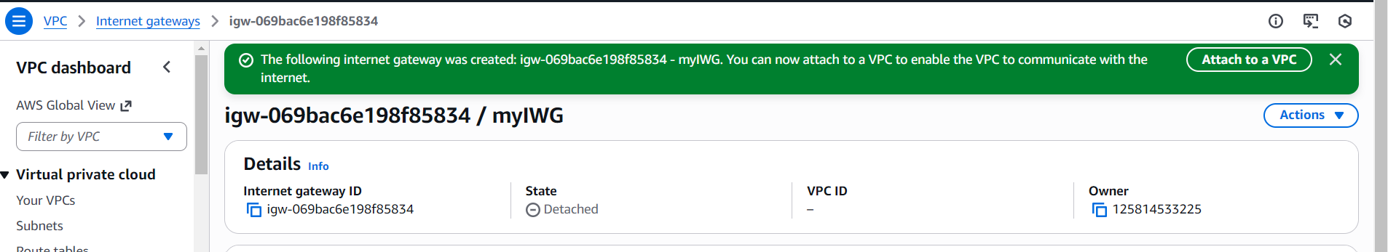

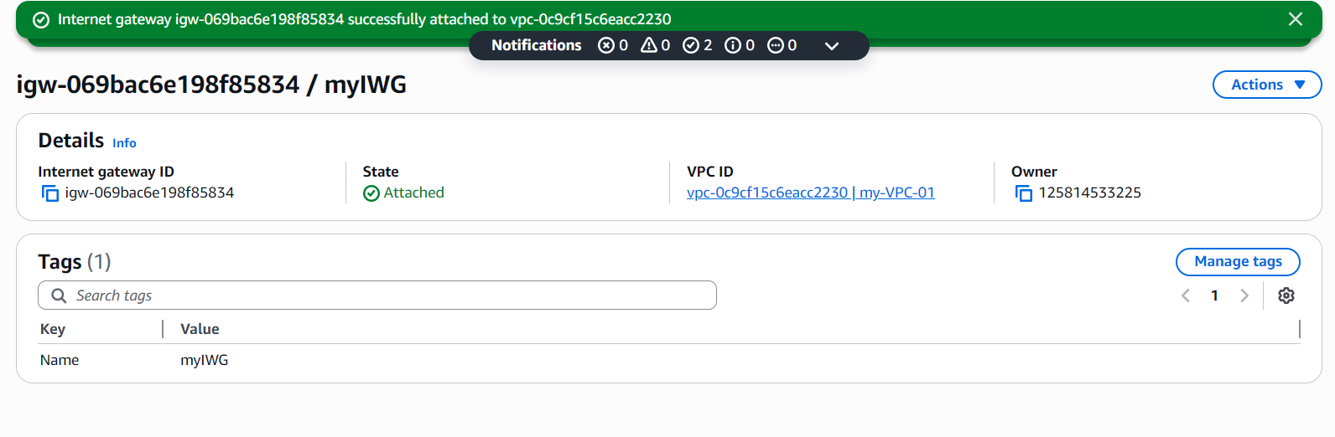

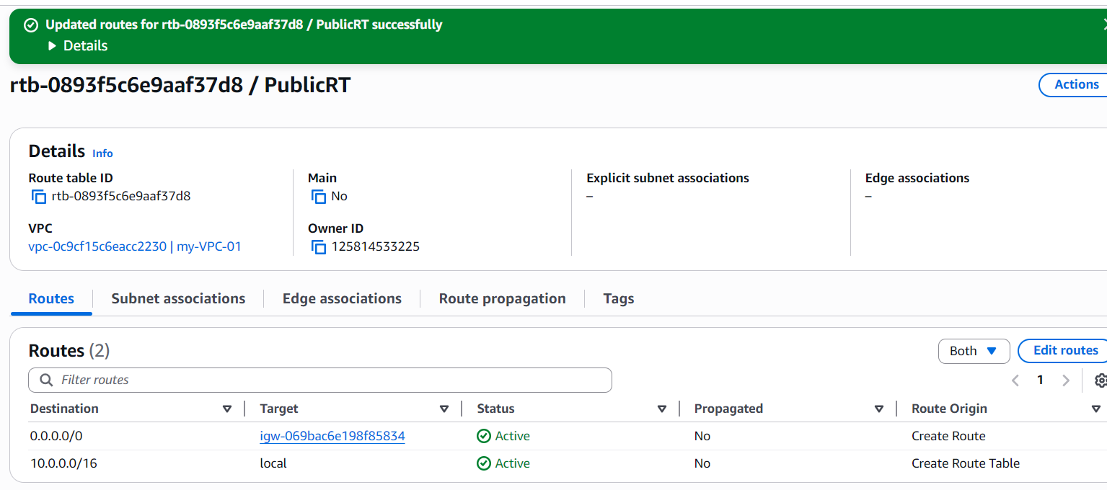
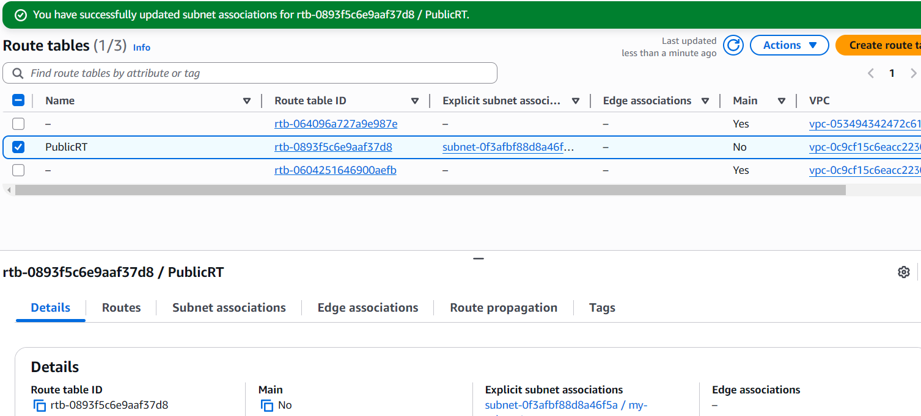

launch a Linux EC2 instance by using the above VPC and public subnet.
